Superstore Sales & Profitability Analysis

1. Introduction
In today's competitive retail environment, understanding sales performance and profitability is essential for effective business decision-making. This project analyzes the Superstore dataset to identify sales trends, profit drivers, regional performance, and product-level profitability.
The primary objective of this analysis is to determine which categories, regions, and sub-categories contribute most to revenue and profit while identifying areas that negatively impact business performance.
The analysis was conducted using Python for data exploration and Tableau for dashboard development and visualization.

2. Dataset Overview
The dataset contains retail transaction records including:

* Sales
* Profit
* Quantity
* Discount
* Category
* Sub-Category
* Region
* State
* City

The dataset consists of 9,994 records covering multiple product categories and regions across the United States.

Data Quality Assessment
The dataset was examined for:

* Missing values
* Duplicate records
* Unique categorical values
* Data consistency

No missing values were identified, indicating a complete dataset suitable for analysis.

3. Business Questions
This analysis aims to answer the following questions:

1. Which product categories generate the highest sales?
2. Which product categories generate the highest profit?
3. Which regions contribute most to sales and profit?
4. What relationship exists between sales, profit, quantity, and discount?
5. Which sub-categories are most profitable?
6. Which products negatively affect profitability?

4. Methodology
The analysis followed four main stages:

Data Understanding
The dataset structure, variable types, and unique values were examined to gain familiarity with the available information.

Data Cleaning
The dataset was inspected for missing values and inconsistencies. No significant data quality issues were found.

Exploratory Data Analysis (EDA)
Exploratory analysis was conducted to investigate:

* Sales performance
* Profit performance
* Regional trends
* Category trends
* Discount effects
* Relationships between key business variables

Dashboard Development
Interactive dashboards were developed in Tableau to communicate findings and support business decision-making.

5. Key Findings

Category Performance
- Technology generated the highest overall sales and profit among all categories.
- Furniture generated strong sales but significantly lower profitability compared to Technology, indicating that high revenue does not necessarily translate into high profit.
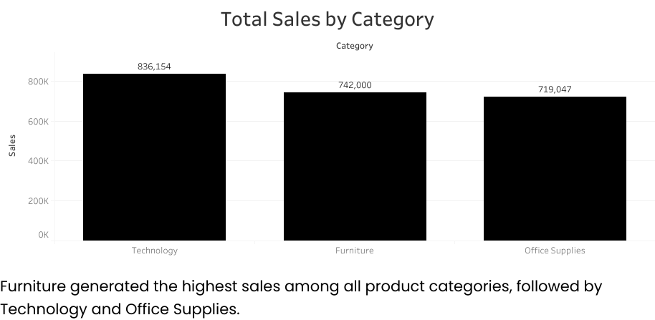

Regional Performance
- The West region recorded the highest sales and profit performance.
- The East region followed closely behind, while the Central and South regions generated comparatively lower profits.
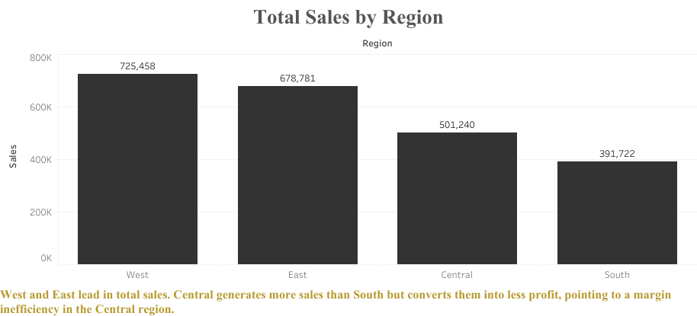

Sales and Profit Relationship
- A positive relationship exists between sales and profit. However, higher sales do not always guarantee higher profitability.
- Several products generated strong revenue while producing relatively weak profit margins.
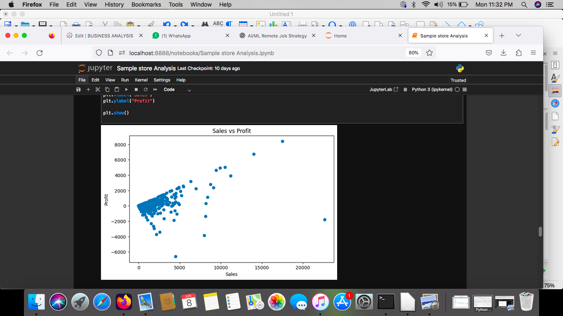

Discount Impact
- Discounting showed a negative relationship with profitability.
- Higher discounts often reduced profit margins, demonstrating the importance of balancing sales growth with profitability objectives.
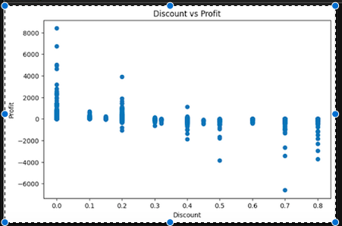

Product-Level Analysis
The most profitable sub-categories were:

* Copiers
* Phones
* Accessories
* Paper
* Binders

The least profitable sub-categories were:

* Tables
* Bookcases
* Supplies

Tables generated the largest overall loss, making them the most critical product area requiring management attention.

6. Recommendations
Based on the findings, the following recommendations are proposed:

Review Loss-Making Products
- Investigate the pricing, discounting, and cost structure of Tables and Bookcases to determine the causes of persistent losses.

Optimize Discount Strategy
- Reduce excessive discounting on products where profit margins are already limited.

Prioritize High-Profit Products
- Increase focus on highly profitable products such as Copiers, Phones, and Accessories through targeted promotions and inventory planning.

Improve Regional Performance
- Further investigate operational practices in lower-performing regions to identify opportunities for profitability improvement.

7. Conclusion

This analysis demonstrates that revenue alone is not a reliable measure of business success. While certain categories and products generate substantial sales, profitability varies significantly across categories, regions, and sub-categories.

The findings highlight the importance of monitoring both sales and profit metrics when making strategic business decisions. Through effective pricing, discount management, and product optimization, organizations can improve profitability while maintaining strong sales performance.

